Module Eight Exercise

The Capital Modeling Approach

Michael Surdek
Southern New Hampshire University
DAT 610: Optimazation & Risk Assessment
Professor Kyle Camac
December 5, 2021
Introduction
Capital modeling is the step in the operational risk management framework where a firm determines the amount of cash reserves necessary to almost certainly cover a year’s worth of losses from operational risks. There are multiple approaches to capital modeling. The basic and standardized approaches are based on gross income, either firm-wide or by business line. The advanced measurement approach incorporates data-based elements such as internal and external losses, scenario analysis, and business environment internal control factors. (Girling, 2013) This approach provides more flexibility to the firm and it leads to more accurate modeling which often lowers the end result of necessary capital. With the insurance losses by make and model dataset from the Insurance Institute for Highway Safety (IIHS), it is possible to follow the three common steps of the advanced measurement approach to determine an amount of capital that would cover the losses from operational risks in the next year for all except 0.1% of possible outcomes.
Average Loss Frequency
The first step in the process is determining loss frequency, which is done by sampling from a distribution that represents the possible number of loss events in a year. The Poisson distribution is often selected and only requires a single parameter, the average number of events per year in the dataset. (Girling, 2013)
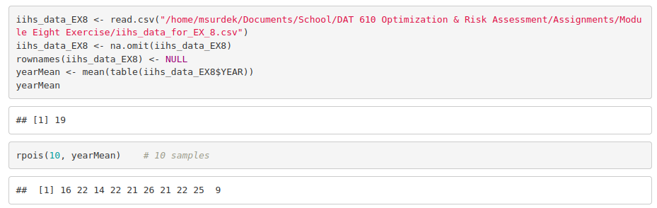
The R code above reads and prepares the IIHS data, creates a yearMean variable of the collision attribute, 19 in this case, which is the Poisson distribution parameter, and then samples 10 values from the distribution that may equal the number of loss events in the next year. With this method, values closer to yearMean are more likely to be sampled, but it is still possible for the number of events to be far from the mean, such as the sampled values of 9 and 26 events.
Average Loss Severity
The next step is to determine loss severity by sampling from a distribution that represents the possible average loss amount per event in a year. Unless the data is limited, a lognormal distribution is a common and straightforward modeling selection. The advanced measurement approach requires that the selected distribution demonstrates a statistical goodness of fit. Additional recommended criteria for the distribution include realistic, well specified, flexible, and simple. (Girling, 2013) The following code shows the calculations of the mu and sigma for the lognormal distribution of average loss severity, which are based on the mean and standard deviation of the collision attribute in the IIHS dataset.
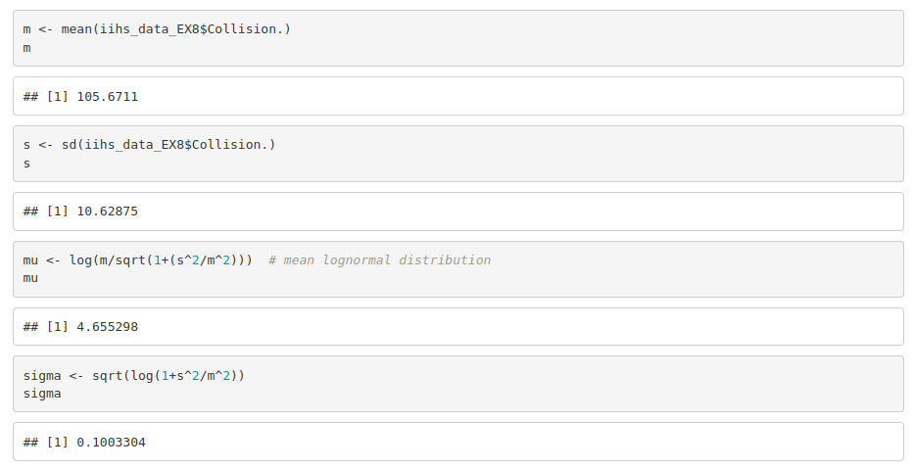
Once mu and sigma are calculated, samples of average loss severity can be generated in a similar way to the frequency above. Although the inputs to are 4.65 and .10, the output are values centered around the originally calculated mean of 105.67.
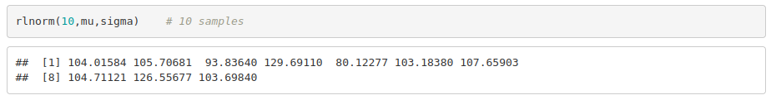
Maximum Total Loss
Monte Carlo Simulation involves iteratively multiplying the sampled frequency and average severity to estimate an outcome of total losses in a year.
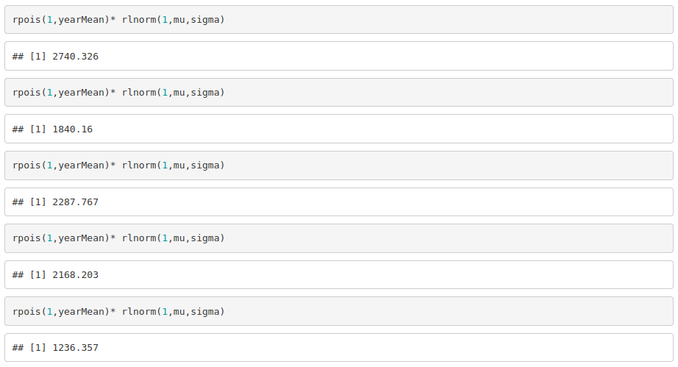
This code simulates five outcomes of a year’s worth of losses for collision insurance. The maximum total loss from the five simulations is 2740.33.
Monte Carlo Extrapolation process
The Monte Carlo Simulation technique can be used to determine the capital required to reach the 99.9% confidence level required by the advanced measurement approach. “The idea behind Monte Carlo is that, as we use more samples, our answers should get more and more accurate.” (Karen, 2021) One way to accomplish this with the IIHS dataset is to generate one million simulations and then pull the 1000th value which is equal to the amount that would cover collision insurance losses in all except 0.1% of years. The value that should be pulled to determine any confidence interval is (1-C)*N, where C is the desired confidence level and N is the number of simulations. In this case, based on (1-.999)*1,000,000, the 1000th value turned out to be 3875.18. This shows how using more samples provides a more accurate calculation than even taking the maximum loss amount from just five simulations.
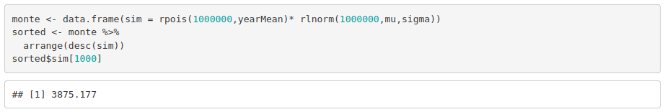
There are two more steps that a firm would realistically have to take to complete the capital modeling process based on the advanced measurement approach. First, since 100 in the dataset is equal to “the average for all passenger vehicles under a given coverage type” (IIHS-HLDI, 2021), the 3875.18 value actualy represents a 3875.18% adjustment to an average collision insurance loss. Therefore, to determine the amount of capital necessary to cover these losses, they must multiply the amount of an average collision loss by 38.7518. The resulting amount will be the actual amount of cash reserves that are necessary for collision coverage. The second and final step would be to repeat the advanced measurement approach process for the other 5 coverage types as well as for any other business lines in which they operate. The final result after repeating this process will be the amount of capital that is necessary to cover the firm’s overall exposure to operational risk at a 99.9% confidence level.
References

Girling, P. X. (2013). Operational Risk Management: A Complete Guide to a Successful Operational Risk Framework. Wiley Professional Development (P&T). Retrieved from https://mbsdirect.vitalsource.com/books/9781118983430

IIHS-HLDI. (2021). Insurance losses by make and model. Insurance Institute for Highway Safety - Highway Loss Data Institute. Retrieved from https://www.iihs.org/ratings/insurance-losses-by- make-and-model

Karen, Tatev. (2021). Monte Carlo Simulation and Variants with Python. Towards Data Science. Retrieved from https://towardsdatascience.com/monte-carlo-simulation-and-variants-with- python-43e3e7c59e1f

